

Matrix Calculator

Done by: Ghazal Helal

Course: Linear Algebra

**Abstract:**

The system below is a matrix calculator that was done using python programming language to do multiple operations like multiplication, transpose and much more.

**Introduction:**

Matrix is the is a rectangular array or table of numbers, symbols, or expressions, arranged in rows and columns, which is used to represent a mathematical object or a property of such an object it consists of n number of rows and n number of columns as well.

Many different operations can be done on the matrices whether one or two or even more there is many libraries that have all kind of operations for the matrices like the numpy library or using the regular functions in python like for loop, recursive function and etc...

**Tools:**

Matrix Operations Script:

This script performs various operations on matrices using Python programming language

It includes functions for adding matrices, multiplying matrices, finding the transpose of a matrix, finding the inverse of a matrix, and finding the determinant of a matrix how the calculator functions:

1. Matrix Input Function (input_matrix):

* Asks the user for the number of rows and columns for a matrix.
* Takes user input for each element in the matrix.

1. Matrix Addition Function (add_matrices):

* Adds two matrices element-wise.

1. Matrix Multiplication Function (multiply_matrices):

* Multiplies two matrices.

1. Matrix Transposition Function (transpose_matrix):

* Switches the rows and columns of a matrix.

1. Matrix Inversion Function (inverse_matrix):

* Attempts to find the inverse of a matrix using NumPy’s linalg.inv function.
* Handles cases where the matrix is not invertible and prints a message.

1. Matrix Determinant Function (determinant_matrix):

* Calculates the determinant of a matrix using NumPy’s linalg.det function.

Example when running the program:

* Takes input for two matrices using the input_matrix() function.
* Prints the entered matrices.
* Calculates and prints the addition, multiplication, and transpose of the first matrix.
* Attempts to find and print the inverse of the first matrix, handling cases where the matrix is not invertible.
* Calculates and prints the determinant of the first matrix.

Snippets of the code:

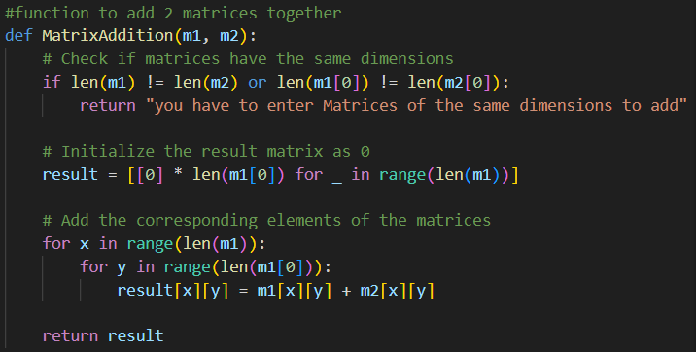

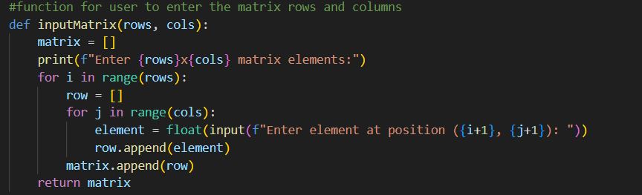

Results:

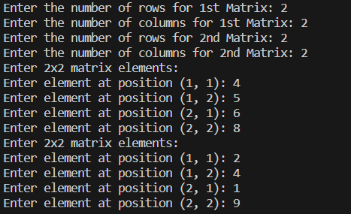

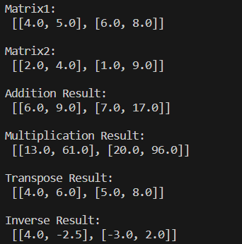

Purpose of The System:

This script allows users to interactively input matrices and perform various mathematical operations on them using all kind of different functions and flexibility of the numbers entered and the size of the wanted matrix.